Zoho Registration

1. Go to: [https://www.zoho.com/](http://www.zoho.com/).

2. Click: SIGN UP NOW.

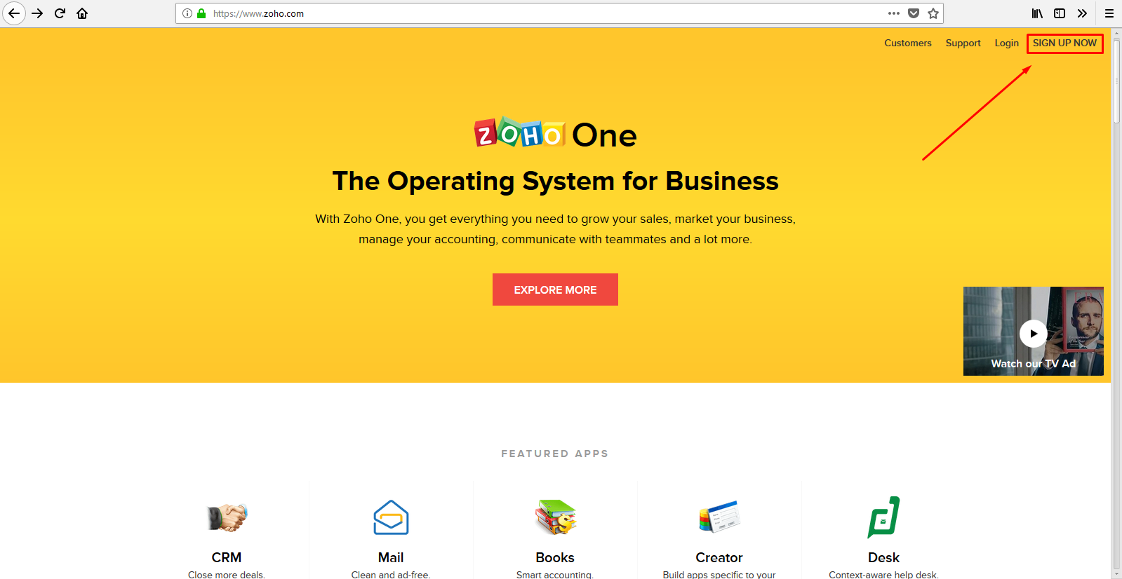

3. Fill the registration form.

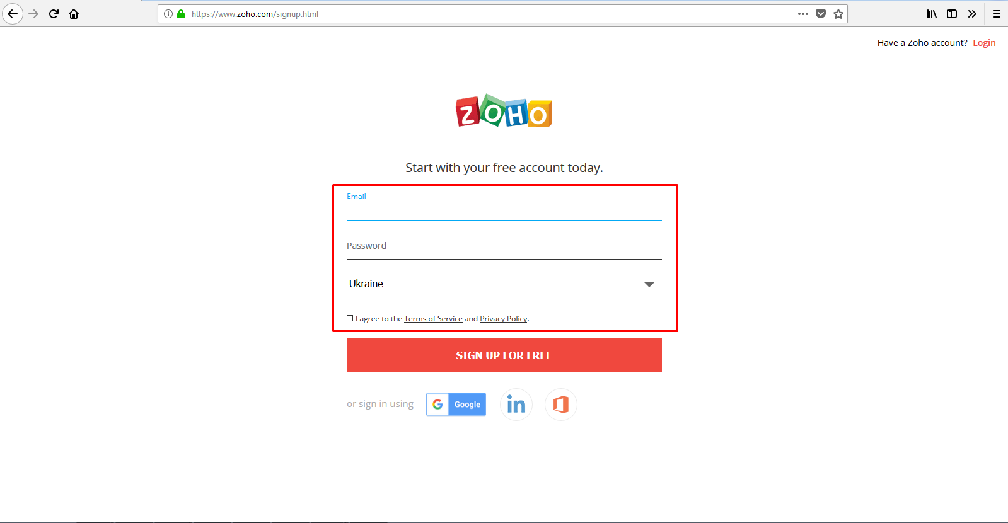

4. Check: “ I agree to the Terms of Service and Privacy Policy”.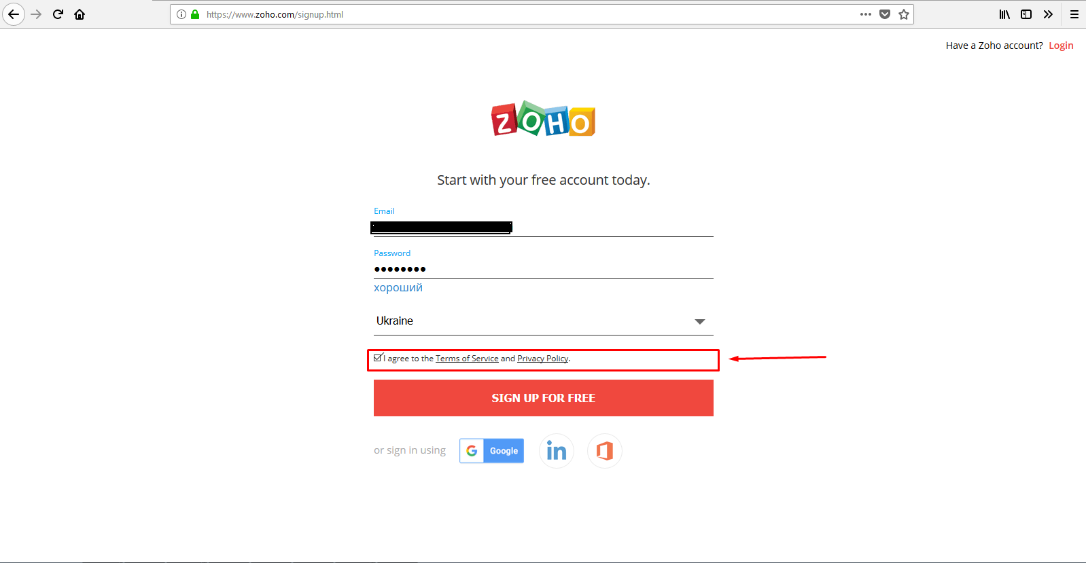

5. Press “SIGN UP FOR FREE”.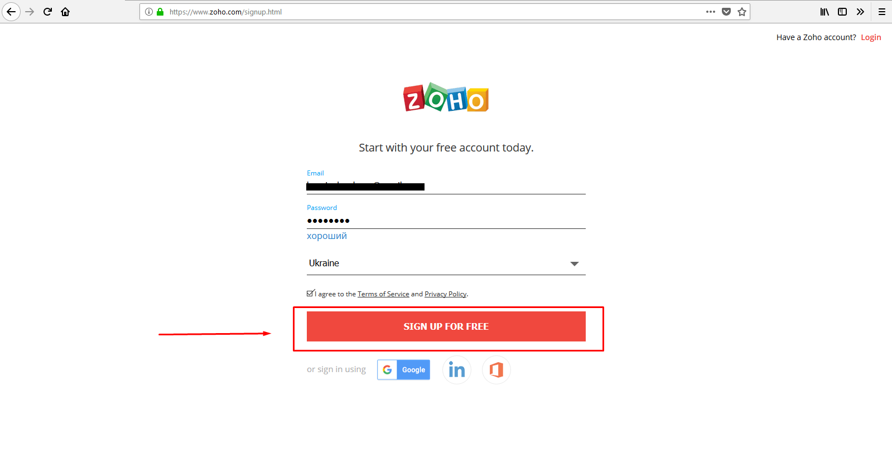

6. Wait while account creating.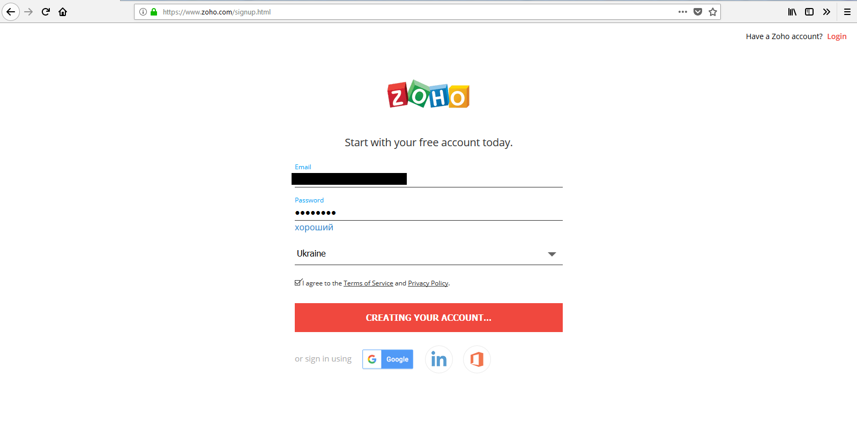

7. After registration, you’ve been redirected to [https://home.zoho.com/home](http://home.zoho.com/home).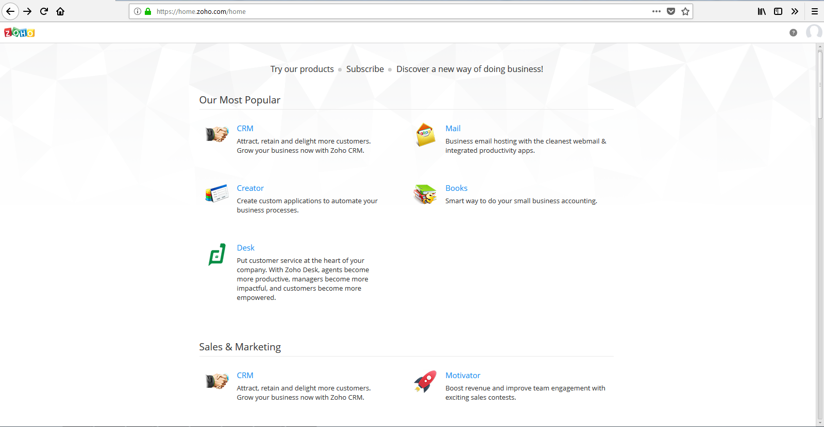

8. At now, Go to [https://accounts.zoho.com/](http://home.zoho.com/home)developerconsole.

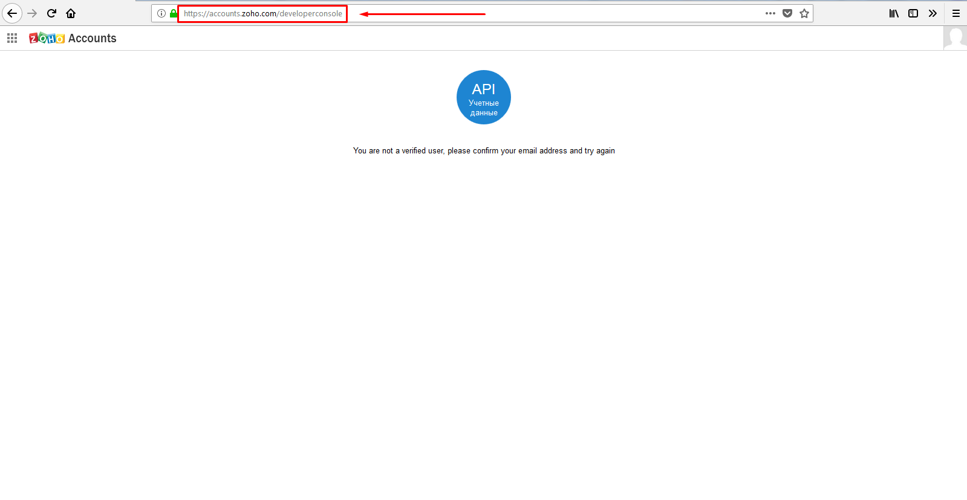

9. Verify your e-mail, if you don’t see “Creating identificator client”.

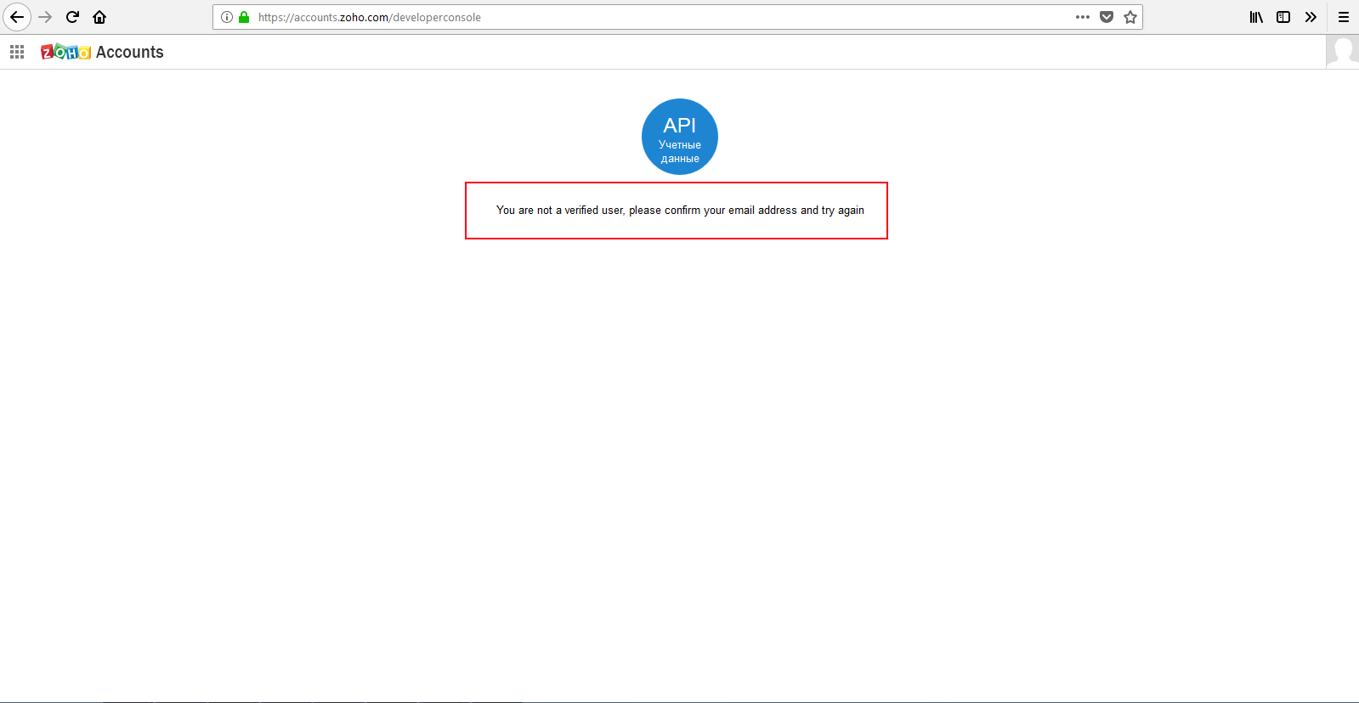

10. After verifying e-mail click on “Creating identificator client”.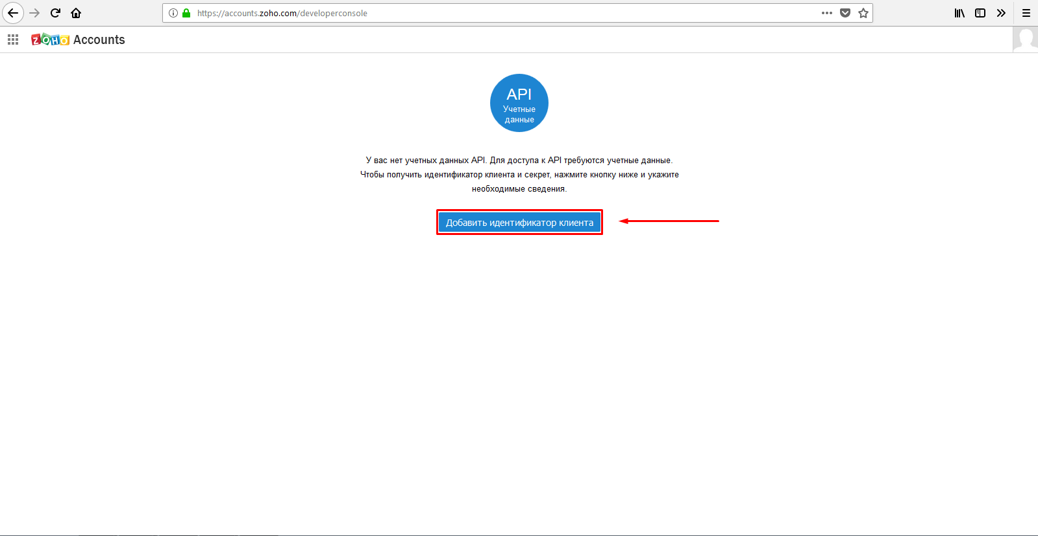

11. Fill the form.

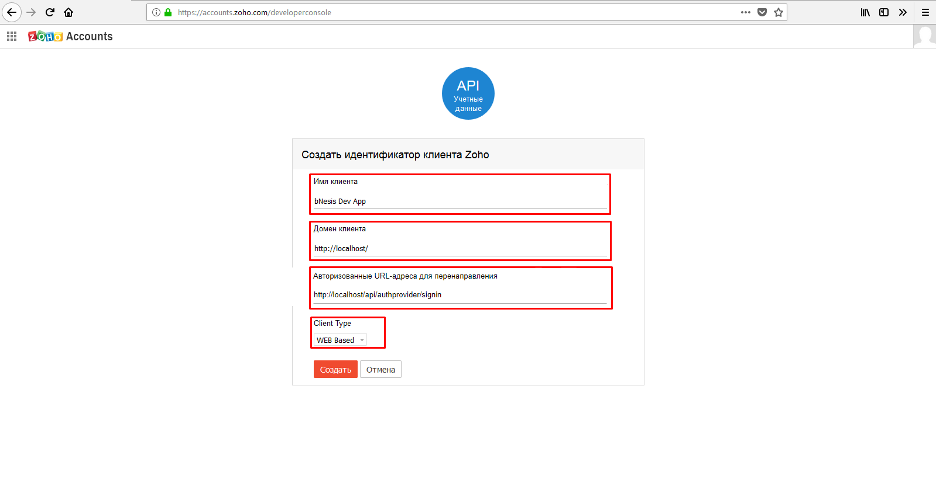

12. Click on “Create”.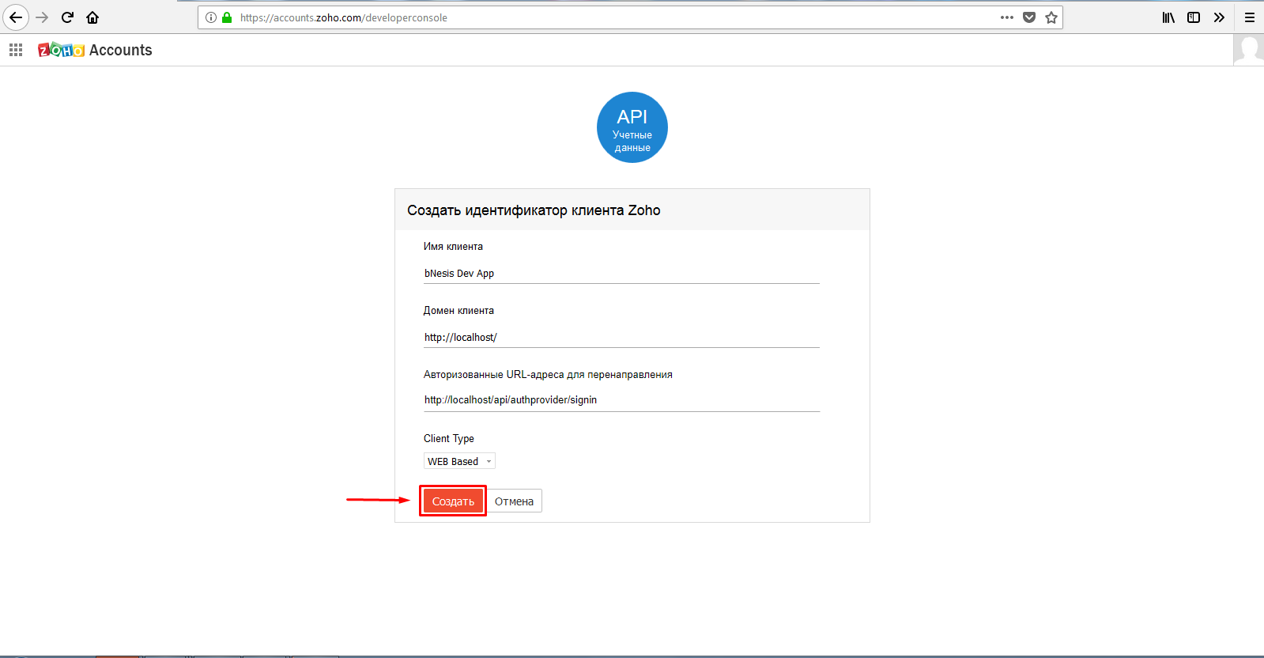

13. Copy client ID & Secret to your app.

